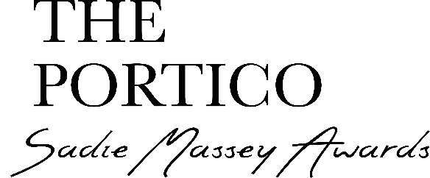

Entry form
Please submit entries by post to The Portico Library or by email as an MP4 video or photographs
Student/s name:

School:

Teacher’s E-mail:

Teacher’s name:

School address:

Key stage:

Year group:

Age:

Gender:

How did you hear about the competition?

What’s the name of your book:

What’s with all the questions?
The information you share won’t go any further and will only be used to process the entries and collect data that can help us to promote the awards to even more young readers and writers. All the information will be held in accordance with data protection guidelines. Entries are judged anonymously.
Please make sure you don’t leave any blanks so we can process your entry during the administration process. Depending on the number of entries we receive we cannot always follow up on incomplete information.
Please send entry forms and video entries (as MP4 videos) or photographs to psma@theportico.org.uk
Entry forms and videos can be sent by wetransfer.
By post to: Art of the Book Award, The Portico Library, 57, Mosley Street, Manchester M2 3HY (please include entry forms)
Tel: 0161 236 6785

One last thing!
We want to do everything we can to help you enter! If you need any assistance or have any questions you can reach us directly by contacting psma@theportico.org.uk and we will answer as soon as we can.
Good luck!

